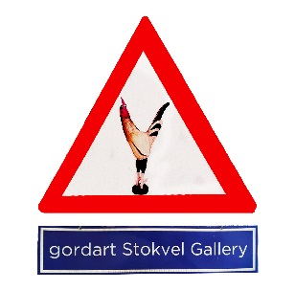
Stokvel Gallery @ 27 Boxes contract
This serves as a formal contract between Stokvel Gallery
(Represented by Gordon Froud)
and Andre Clements (Artist/ Curator).
I ………………………………………………………… accept the terms and dates to host an exhibition of my choice from 12 March 2025
(opening Sat 15 March) to 17 March 2025
Signed…………………………………………………… Date: ……………………………………………
The cooperative (Stokvel Gallery) undertakes to provide the space, basic infrastructure (like glasses, tablecloths, chairs, etc), sending out invites on mailing list and social media, within their capabilities.
The Artist/Curator undertakes to pay the once off participation fee of R900 and to pay 25% of any sales to Stokvel. All sales must go through the Stokvel Yoco machine (5% charged – included in the 25%). From there the remaining 20% commission will be deducted and paid to 27 Boxes and the Artist’s/ Curator’s remainder be paid on invoice to the artist/ curator/ organizer. The R900 participation fee includes the assistance of Khuks on the Saturday to serve drinks, clean glasses and assist where he can. This leaves the artist free to sell and be with their friends and clients.
The space is an artist run initiative where the artist/curator/creator manages their time and the space as they see fit. The gallery is 9x4m with a glass front. All proceeds of sales are for the artist and no commission is due to the Stokvel. The Stokvel does not conduct sales, guarantee sales or attendance – this remains the jurisdiction of the signatory, although invitations and information will be sent out on our mailing list and on social media on which we have a presence. Signatories are responsible for opening function refreshments, peopling the space (I have students available to sit in the gallery and to serve and cleanup if required at R350 a day) and for clearing up after an opening as well as returning cleaned glasses. Breakages will be deducted from your payment.
The Stokvel is advertised as a “Weekend Special” Gallery – implying that it will be open on weekends (10am to 4pm daily) only, with an opening every Saturday. Your show runs to Sunday afternoon, but you are at liberty to use the space from Wednesday 11 March if you want to work there, host private functions or for any other activity like workshops, talks etc. The gallery has already paid for and installed lighting, signage, a desk and chair and a fridge for your use and we cover the electricity consumption. There is underground parking for guests (This may be charged by the center) and street parking on 3rd and 4th Ave Melville. There are restaurants, coffee shops, bookshops, clothing and a variety of other shops in the 27 Boxes complex. Some of these might yield foot traffic and sales.
The signatory agrees to return the space to the Stokvel in the same condition it was received within 1 day of their show closing, including patching and painting holes, for which paint is provided. (The Tuesday after – as the next artist moves in on the Wednesday).
Please make your R900 payment by 5th of the month as per your agreement to:
Gordon C Froud
Capitec
Debit account 1763530823
Reference: Stokvel and your name.

Please adhere to payment dates as the Stokvel does not have an administrator to chase up non payments – this could affect the whole Stokvel and is done in trust.

I look forward to your show
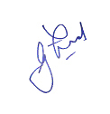
Gordon Froud 0844238635
stokvelgallery@gmail.com

